DCC-GARCH correlation: GBPUSD and USDJPY
Method 09 / GARCH(1,1) + Engle DCC / Alpari D1 full available history

Study setup
Logical pair: GBPUSD , USDJPY
Broker symbols: GBPUSD_i , USDJPY_i
Snapshot: 2026-11-03_majors_alpari_D1
Timeframe: D1
Matched return window: 1999-01-05 to 2026-11-02 (UTC bar dates)
Matched return count n: 7200
Dropped unfinished last bar dated 2026-11-03 UTC after a tick-volume check against the prior complete day.
GBPUSD GARCH(1,1): mu=0.000021, omega=0.004027, alpha=0.055334, beta=0.932275
USDJPY GARCH(1,1): mu=0.000110, omega=0.005012, alpha=0.051983, beta=0.935331
DCC: a=0.026275, b=0.966438, a+b=0.992713
Burn-in ignored in path summaries and chart: first 60 updates
Complete matched rows (Excel): GBPUSD-USDJPY_DCC_D1.xlsx
Complete matched rows (HTML table): GBPUSD-USDJPY_DCC_D1_data.html

Method carried forward
DCC-GARCH first fits a constant-mean GARCH(1,1) on each matched daily log return of close, ln(close_t / close_t-1), then updates Engle (2002) dynamic conditional correlation on the standardised shocks z = residual / conditional sigma. Quotes are not inverted. Correlation targeting sets Q_bar to the sample correlation of z; a and b are estimated by maximising the bivariate Gaussian DCC likelihood with a >= 0, b >= 0, and a + b < 1. Path summaries ignore the first 60 updates. The headline is rho on the last day. Same-sample Pearson r on log returns is a side check only. A high |rho| does not prove cause, lead-lag, or a trading signal.

Results
Latest DCC rho: -0.400230
Post-burn-in path (n=7140): mean=-0.272957, median=-0.283804, min=-0.659121, max=0.470469, std=0.197105
Share of post-burn-in days with |rho| >= 0.4: 28.96%; |rho| >= 0.7: 0.00%
Same-sample Pearson r: -0.198556
Latest rho minus r: -0.201675

Conclusion
Over 7200 matched daily log-return rows for GBPUSD and USDJPY (broker quote directions unchanged), latest DCC rho is -0.4002 (negative, moderate conditional linear link in this sample) with fitted a=0.0263, b=0.9664 (a+b=0.9927). After a 60-day burn-in, path mean is -0.2730 and std is 0.1971. Same-sample Pearson r is -0.1986 (latest rho minus r = -0.2017). This does not establish cause, lead-lag, or a lasting trading rule.

Charts
Daily closes

Daily log returns
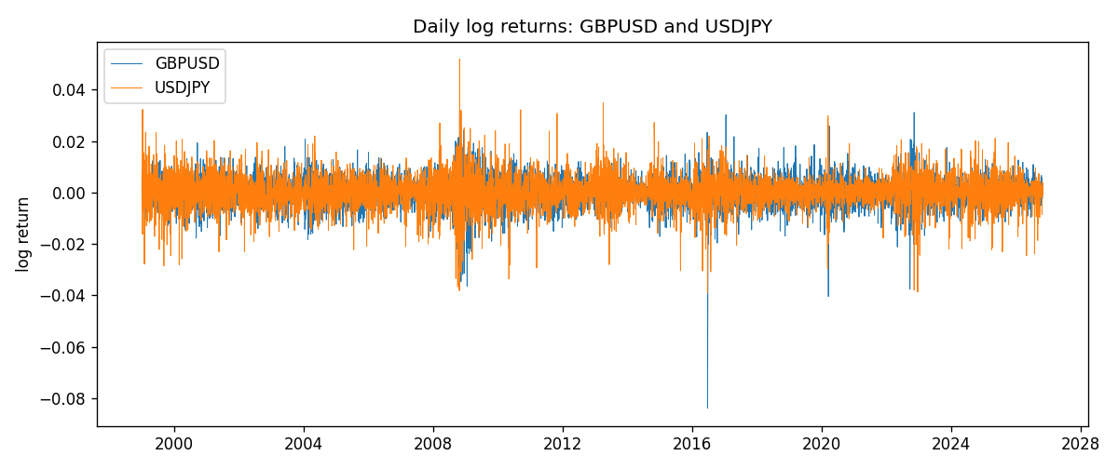
DCC rho path with Pearson r reference
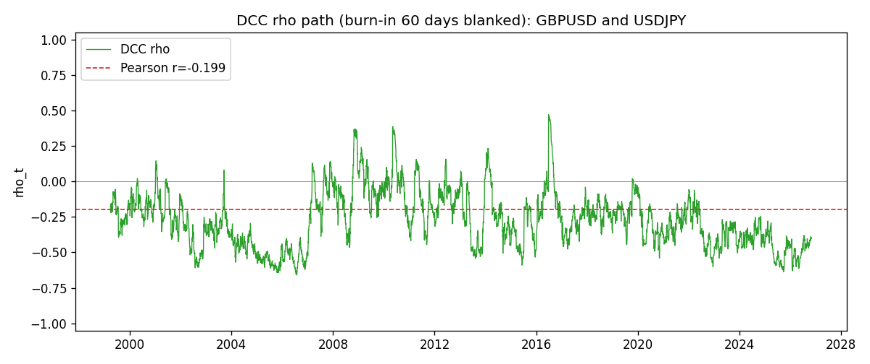

Data report
Every matched row that entered the DCC recursion is stored in the sibling Excel workbook named GBPUSD-USDJPY_DCC_D1.xlsx. Embedding all rows as a Word table is impractical at this length; the Word file holds the column list, column summaries, and the first and last 15 matched rows.
Columns: time, GBPUSD_open, USDJPY_open, GBPUSD_high, USDJPY_high, GBPUSD_low, USDJPY_low, GBPUSD_close, USDJPY_close, GBPUSD_tick_volume, USDJPY_tick_volume, GBPUSD_spread, USDJPY_spread, GBPUSD_real_volume, USDJPY_real_volume, GBPUSD_log_return, USDJPY_log_return, GBPUSD_sigma, USDJPY_sigma, GBPUSD_z, USDJPY_z, q11, q22, q12, rho_t
Column summaries (matched calculation rows)
column | count | mean | std | min | 25% | 50% | 75% | max
GBPUSD_open | 7200 | 1.5159933 | 0.21821503 | 1.06854 | 1.3249725 | 1.51133 | 1.63163 | 2.1066
USDJPY_open | 7200 | 113.81122 | 19.205564 | 75.693 | 104.42925 | 110.991 | 120.69125 | 163.824
GBPUSD_high | 7200 | 1.5222906 | 0.21878569 | 1.08366 | 1.329785 | 1.518035 | 1.638315 | 2.1161
USDJPY_high | 7200 | 114.30876 | 19.267108 | 76.001 | 104.8815 | 111.4435 | 121.26 | 163.978
GBPUSD_low | 7200 | 1.5096683 | 0.2174426 | 1.03518 | 1.319445 | 1.50319 | 1.6243 | 2.0983
USDJPY_low | 7200 | 113.28793 | 19.133561 | 75.402 | 103.89 | 110.5305 | 120.17 | 163.628
GBPUSD_close | 7200 | 1.5160611 | 0.21817876 | 1.06879 | 1.3250775 | 1.511235 | 1.63193 | 2.1065
USDJPY_close | 7200 | 113.82409 | 19.220954 | 75.811 | 104.42 | 111.028 | 120.6855 | 163.851
GBPUSD_tick_volume | 7200 | 94838.03 | 153554.65 | 62 | 10001.75 | 52905.5 | 91812.25 | 1273370
USDJPY_tick_volume | 7200 | 106136.9 | 179308.31 | 149 | 9925 | 53095 | 92761 | 1803508
GBPUSD_spread | 7200 | 26.967917 | 19.192953 | 0 | 11 | 20 | 50 | 50
USDJPY_spread | 7200 | 20.325556 | 17.633971 | 0 | 6 | 11 | 30 | 50
GBPUSD_real_volume | 7200 | 3.5565837e+09 | 8.4444068e+10 | 0 | 0 | 0 | 0 | 2.4038164e+12
USDJPY_real_volume | 7200 | 3.470121e+10 | 1.6077679e+11 | 0 | 0 | 0 | 0 | 3.8834203e+12
GBPUSD_log_return | 7200 | -2.396e-05 | 0.00564572 | -0.08388241 | -0.0031301 | 3.232e-05 | 0.00317911 | 0.03112653
USDJPY_log_return | 7200 | 4.769e-05 | 0.00620489 | -0.03908203 | -0.00320192 | 0.00011421 | 0.00340709 | 0.05184024
GBPUSD_sigma | 7200 | 0.00539738 | 0.00169183 | 0.00300578 | 0.00447948 | 0.00503976 | 0.00577871 | 0.02198508
USDJPY_sigma | 7200 | 0.005992 | 0.0017394 | 0.0033733 | 0.00477801 | 0.00569209 | 0.00679031 | 0.01882466
GBPUSD_z | 7200 | -0.00693688 | 1.0000213 | -10.312112 | -0.60076501 | 0.00254475 | 0.60692586 | 4.945389
USDJPY_z | 7200 | -0.00898837 | 1.0002803 | -6.5286361 | -0.5646688 | 0.00064387 | 0.58099606 | 7.1026381
q11 | 7200 | 1.0009531 | 0.20794369 | 0.57399658 | 0.89306867 | 0.97796773 | 1.0704744 | 4.1737165
q22 | 7200 | 1.0012549 | 0.21859839 | 0.54295919 | 0.8528722 | 0.97824341 | 1.1125276 | 2.0851809
q12 | 7200 | -0.26424441 | 0.21909375 | -0.95132512 | -0.40962271 | -0.2693273 | -0.13718187 | 1.3007891
rho_t | 7200 | -0.27191411 | 0.19669878 | -0.65912072 | -0.42048802 | -0.28125297 | -0.15335647 | 0.4704685
First 15 matched rows (selected columns)
time | GBPUSD_log_return | USDJPY_log_return | GBPUSD_sigma | USDJPY_sigma | GBPUSD_z | USDJPY_z | q11 | q22 | q12 | rho_t
1999-01-05 | -0.0028966287 | -0.00017868311 | 0.0040779586 | 0.011227609 | -0.71537759 | -0.025708725 | 1 | 1 | -0.26441865 | -0.26441865
1999-01-06 | -0.00060452184 | 0.0075660159 | 0.0040468664 | 0.010881755 | -0.15448333 | 0.6851883 | 0.98717187 | 0.97374286 | -0.25698795 | -0.26211643
1999-01-07 | -0.002118709 | -0.012851583 | 0.0039613534 | 0.010683915 | -0.54005798 | -1.2131832 | 0.96195494 | 0.96068502 | -0.25307103 | -0.26325375
1999-01-08 | -0.0058954193 | -0.0047719894 | 0.0039096704 | 0.010770272 | -1.5131891 | -0.45328046 | 0.94462058 | 0.97440117 | -0.22928963 | -0.2389939
1999-01-11 | -0.0056851331 | -0.016195423 | 0.0040730468 | 0.010499398 | -1.400864 | -1.552983 | 0.98036653 | 0.95438425 | -0.20549949 | -0.21244909
1999-01-12 | 0.0022657001 | 0.032310364 | 0.0042036102 | 0.010836517 | 0.53407629 | 2.9714713 | 1.0063126 | 0.99300839 | -0.14336878 | -0.14342065
1999-01-13 | 0.0091330396 | 0.0081373171 | 0.0041418861 | 0.012815481 | 2.2000576 | 0.62637937 | 0.98732068 | 1.198963 | -0.098786512 | -0.090795774
1999-01-14 | 0.0019376331 | 0 | 0.004581572 | 0.012548562 | 0.4184113 | -0.0087631072 | 1.088647 | 1.1763198 | -0.061189817 | -0.054072059
1999-01-15 | -0.0017558204 | 0.0055343401 | 0.0044916869 | 0.012156687 | -0.39550217 | 0.44620509 | 1.0639972 | 1.1441297 | -0.061159402 | -0.055431338
1999-01-18 | 0.0012112405 | 8.7600193e-05 | 0.0044029782 | 0.011843085 | 0.27040536 | -0.0018883767 | 1.0396847 | 1.1182492 | -0.065670467 | -0.060904584
1999-01-19 | 0.0018745281 | -0.0056219403 | 0.0043074854 | 0.011475604 | 0.43038488 | -0.49948609 | 1.0139995 | 1.0880061 | -0.065406753 | -0.062271318
1999-01-20 | -0.0049053846 | -0.0053879917 | 0.0042297417 | 0.011197426 | -1.1646187 | -0.49100178 | 0.99212198 | 1.0653331 | -0.070786738 | -0.0688536
1999-01-21 | 0.0031518998 | 0.0084664056 | 0.0042923775 | 0.010924583 | 0.72949041 | 0.76492086 | 1.0017489 | 1.0432002 | -0.055313347 | -0.054108645
1999-01-22 | 0.0024781662 | 0.0060412564 | 0.0042569883 | 0.010759166 | 0.5772895 | 0.55127803 | 0.98939789 | 1.0308492 | -0.040722579 | -0.040322944
1999-01-25 | 0.0012066366 | -0.0073594164 | 0.0041989918 | 0.010516823 | 0.2824452 | -0.71023166 | 0.97223553 | 1.0115243 | -0.032920959 | -0.03319698
Last 15 matched rows (selected columns)
time | GBPUSD_log_return | USDJPY_log_return | GBPUSD_sigma | USDJPY_sigma | GBPUSD_z | USDJPY_z | q11 | q22 | q12 | rho_t
2026-10-13 | 0.0036434319 | -0.0018932826 | 0.0036719468 | 0.0048729916 | 0.98661023 | -0.41109181 | 0.77075195 | 0.93873539 | -0.35425411 | -0.41647218
2026-10-14 | -0.0049164679 | 7.5800166e-05 | 0.0037012143 | 0.0047875086 | -1.3339188 | -0.0071361194 | 0.77774701 | 0.91895732 | -0.35494822 | -0.41985386
2026-10-15 | 0.0065976411 | -0.0018524319 | 0.0038108674 | 0.0046839393 | 1.7258511 | -0.4189628 | 0.80568298 | 0.89540409 | -0.34471231 | -0.40584963
2026-10-16 | 0.0037592051 | -0.00037976126 | 0.0040417134 | 0.0046067232 | 0.92499223 | -0.10630672 | 0.86419034 | 0.87725196 | -0.35406828 | -0.40664941
2026-10-19 | -0.0017500314 | 0.0034946841 | 0.0040503372 | 0.0045125585 | -0.43716928 | 0.75006666 | 0.8649546 | 0.85539402 | -0.34669566 | -0.40305902
2026-10-20 | 0.0055923442 | -0.0022546642 | 0.0039837651 | 0.004488103 | 1.3985997 | -0.52686594 | 0.84823395 | 0.84875478 | -0.3456024 | -0.40731256
2026-10-21 | 0.0012476328 | -0.00032883504 | 0.0041129129 | 0.0044308369 | 0.29832416 | -0.099033084 | 0.87844805 | 0.83484981 | -0.35529128 | -0.41487983
2026-10-22 | 0.00022396082 | -0.0085942669 | 0.0040319257 | 0.0043444148 | 0.050424854 | -2.0035452 | 0.8585914 | 0.81437572 | -0.34607021 | -0.41386485
2026-10-23 | -0.0021146949 | 0.00035080446 | 0.003944674 | 0.0047003208 | -0.54132394 | 0.051239069 | 0.83712962 | 0.89980205 | -0.33903685 | -0.39064031
2026-10-26 | -0.0024340661 | 0.0041238746 | 0.0038937946 | 0.0046009255 | -0.63041787 | 0.87241366 | 0.82402059 | 0.87695934 | -0.33031383 | -0.38856887
2026-10-27 | -0.0023648393 | 0.0027651658 | 0.0038562865 | 0.0045976415 | -0.61859794 | 0.57751379 | 0.81409445 | 0.87481197 | -0.33560539 | -0.39768039
2026-10-28 | 0.0015771808 | -0.00095679538 | 0.0038185601 | 0.0045430184 | 0.40762203 | -0.234813 | 0.80411355 | 0.86150213 | -0.33565531 | -0.40327997
2026-10-29 | 0.0035881935 | -0.00038043789 | 0.0037590751 | 0.0044569816 | 0.94904781 | -0.11003014 | 0.788779 | 0.84132455 | -0.32883187 | -0.40365883
2026-10-30 | 0.0013450605 | -0.0010596481 | 0.0037789698 | 0.0043696424 | 0.35046824 | -0.26766779 | 0.79325867 | 0.82069356 | -0.32246627 | -0.39965602
2026-11-02 | 0.0010971256 | 0.0026438521 | 0.0037166147 | 0.0042931724 | 0.28963831 | 0.59021334 | 0.77715001 | 0.80231936 | -0.3160354 | -0.40023003

